Listening Vocabulary

🎧 What is Listening Vocabulary
# Source: Chatgpt (GPT-4-turbo) at [7/30/2025]
Listening vocabulary refers to the words you can understand when heard in spoken language. It is a subtype of receptive vocabulary, as it relies on comprehension without necessarily using the words in speech or writing.

✅ Key Features:
# Source: Chatgpt (GPT-4-turbo) at [7/30/2025]
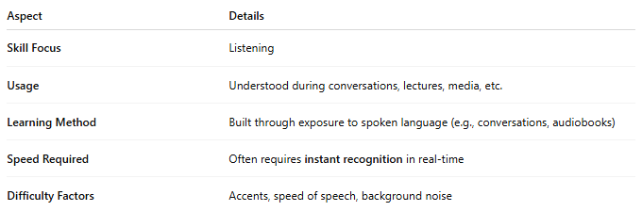
Aspect | Details
Skill Focus | Listening
Usage | Understood during conversations, lectures, media, etc.
Learning Method | Built through exposure to spoken language (e.g., conversations, audiobooks)
Speed Required | Often requires instant recognition in real-time
Difficulty Factors | Accents, speed of speech, background noise

🧠 Example:
# Source: Chatgpt (GPT-4-turbo) at [7/30/2025]
- You hear the sentence: “The lecture was quite enlightening.”
👉 You understand the word “enlightening” without needing to use it yourself.

👤 Who Uses It?
# Source: Chatgpt (GPT-4-turbo) at [7/30/2025]
- Everyone, but especially:
  - Language learners trying to keep up with native speech
  - Children developing early language skills
  - Professionals listening to meetings or presentations

📌 Related Concepts:
# Source: Chatgpt (GPT-4-turbo) at [7/30/2025]
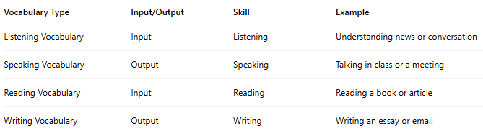

Vocabulary Type | Input/Output | Skill | Example
Listening Vocabulary | Input | Listening | Understanding news or conversation
Speaking Vocabulary | Output | Speaking | Talking in class or a meeting
Reading Vocabulary | Input | Reading | Reading a book or article
Writing Vocabulary | Output | Writing | Writing an essay or email

